**EXPLORING THE PROFIT FROM THE STARTUP’S DATASET WITH COGNOS ANALYSIS**

**TARGET VARIABLE:** Profit

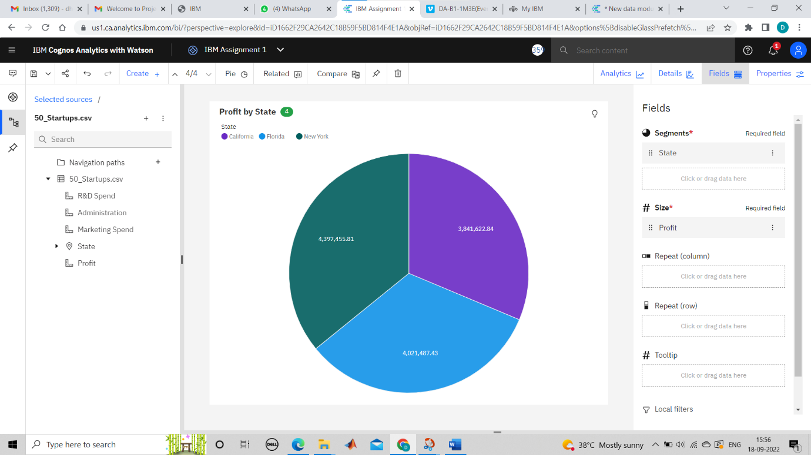

From the above pie chart,

* Profit in newyork is high.
* Startups in newyork is high

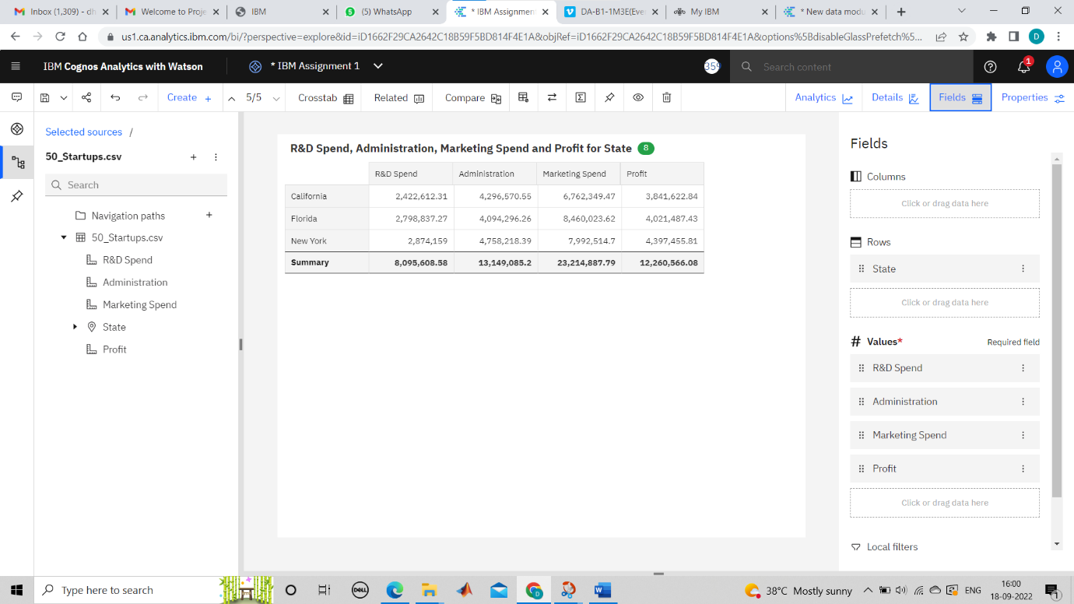

From observing the charts,

* R and D is directly proportional to profit
* Profit is high where R and D is high
* Florida spends more on R and D and marketing
* New york spends lesser in R and D than other states

**COGNOS ANALYTICS LINK:** <https://us1.ca.analytics.ibm.com/bi/?perspective=explore&pathRef=.my_folders%2FIBM%2BAssignment%2B1&subView=model000001835013cf8a_00000004>